ASSIGNMENT NO 01

Submitted To:
“Prof. Toqeer Sb”
Subject:
WEB
Submitted By:
“Umair Azmat”
Roll No:
4523

BSSE 5TH MOR (A)



Government College University Faisalabad
Sample For Assignmet

Moving Images
Or Text
Home  Contact  Feedback | Image Text  Text Image

Main Index File

<!DOCTYPE html>
<html>

<head>
<title>Umair 4523</title>
</head>
<!-- Frame Set -->
<frameset rows="25%,75%">
<!-- Top Frame Set -->
<frame name="top" src="header.html" />
<!-- Left & Right Set -->
<frameset cols="20%, 80%">
<frame name="left" src="leftdesign.html" />
<frame name="right" src="rightdesign.html" />
</frameset>
</frameset>

</html>

Header File Code

<!DOCTYPE html>
<html lang="en">

<head>
<meta charset="UTF-8">
<meta http-equiv="X-UA-Compatible" content="IE=edge">
<meta name="viewport" content="width=device-width, initial-scale=1.0">
<title>Header</title>
</head>

<body bgcolor="#E6E6FA">
<!-- Marquee Text -->
<marquee behavior="scroll" direction="right" scrollamount="10">
Welcome To Digital World
</marquee>
<!-- Marquee Images -->
<marquee behavior="alternate" direction="left">
<img src="wordpress.jpg" width="120px" height="80px" alt="Natural" scrollamount="10" />
<img src="android.png" width="120px" height="80px" alt="Natural" scrollamount="10" />
<img src="google (1).png" width="120px" height="80px" alt="Natural" scrollamount="10" />
<img src="apple.jpg" width="120px" height="80px" alt="Natural" scrollamount="10" />
</marquee>
<!-- Marquee Text -->
<marquee behavior="scroll" direction="right" scrollamount="10">
<h5>We build powerful digital solutions and
experiences...</h5>
</marquee>
</marquee>

</body>

</html>

Left Design Code
<!DOCTYPE html>
<html lang="en">

<head>
<meta charset="UTF-8">
<meta http-equiv="X-UA-Compatible" content="IE=edge">
<meta name="viewport" content="width=device-width, initial-scale=1.0">
<title>Document</title>
</head>

<body bgcolor=" CAD7DF">
<br>
<br>
<br>
<hr color="black">
<!-- Menu Butoons -->
<ul><a href="home.html" target="_blank">
<h2>Home
<hr color=" black">
</h2>
</a></ul>
<ul><a href="contact.html" target="_blank">
<h2>Contact
<hr color="black">
</h2>
</a></ul>
<ul><a href="feedback.html" target="_blank">
<h2>FeedBack
<hr color=" black">
</h2>
</a></ul>
<hr color="black">
</body>

</html>
Right Design Code
<!DOCTYPE html>
<html lang="en">

<head>
<meta charset="UTF-8">
<meta http-equiv="X-UA-Compatible" content="IE=edge">
<meta name="viewport" content="width=device-width, initial-scale=1.0">
<title>Document</title>
</head>

<body align="center" background="gradient.jpg">
<!-- Table -->
<table align="center" width="600px" border="1px solid " bordercolor="white">
<!-- Table Caption -->
<caption>
<h3>Welcone To Solution Hub Designed and Powered By Azuuza</h3>
</caption>
<tr>
<!-- Left image in table -->
<td><a href="img12.jpg" target="_blank"><img src="img12.jpg" alt="" height="200px" width="250px"></a></td>
<td>
<!--Right Text in Table -->
<h5>Website Development
</h5>
<p>We create beautifully designed web apps precisely tailored to your situation. From providing Software as a Service to creating custom software to support your customers, our Web App team will get you up and running.</p>
</td>
</tr>
<tr>
<td>
<!--Left Text in Table -->
<h5>Mobile App Development
</h5>
<p>US consumers spend nearly a quarter of their day on their mobile phone – and 92% of that time is spent using apps. Your app needs to be brilliantly designed and intuitive to have a shot at getting anyone’s attention.</p>
</td>
<!-- Right image in table -->
<td><a href="img2.jpg" target="_blank"><img src="img2.jpg" alt="" height="200px" width="250px"></a></td>
</tr>
<tr>
<td colspan="2">
<p>We are always here to serve you some awesome services</p>
</td>
</tr>
</table>
</body>

</html>
Home Page Design Code
<!DOCTYPE html>
<html lang="en">

<head>
<meta charset="UTF-8">
<meta http-equiv="X-UA-Compatible" content="IE=edge">
<meta name="viewport" content="width=device-width, initial-scale=1.0">
<title>Home Page</title>
</head>

<body bgcolor="#add8e6" align="center">
<hr color="3A6585" width="500px">
<hr color="977865" width="300px">
<h1 align="center">Home Page</h1>
<hr color="977865" width="300px">
<hr color="3A6585" width="500px">
<h2>Welcome To The World Largest Development Hub</h2>
<p>A TRUE LEADER CAN <b>HELP YOU IN BUSINESS</b></p>
<hr width="350px" color="5E6870">
<img src="Home1.jpg" alt="" width="100%">

</body>

</html>
Feedback Design Code
<!DOCTYPE html>
<html lang="en">

<head>
<meta charset="UTF-8">
<meta http-equiv="X-UA-Compatible" content="IE=edge">
<meta name="viewport" content="width= <form action=" /">
<title>FeedBack From</title>
</head>

<body bgcolor="#99badd">
<form action="">
<!-- Feedback Table -->
<table width="1000px" align="center" border="1px solid black" bordercolor="white">
<!-- Caption -->
<caption>
<hr color="#0000ff" width="500px">
<hr color="black" width="300px">
<h1>Customer FeedBack Form</h1>
<p>Please help us improve our services by filling in our feedback form. Thank you!</p>
<hr color="black" width="300px">
<hr color="#0000ff" width="500px">

</caption>

<!-- Name -->
<!-- Email -->
<tr align="left">
<th>
Name
</th>
<th>
Email
</th>
</tr>
<tr>
<td><input type="text" name="name" placeholder="First Name" />
<input type="text" name="name" placeholder="Last Name" />
</td>
<td>
<input type="text" name="name" placeholder="abcperson@gmail.com" />
</td>
</tr>
<!-- Services -->
<!-- Ordered Date -->
<tr align="left">
<th>
Services You Hired<span>*</span>
</th>
<th>
Ordered Date
</th>

</tr>
<tr>
<td>
<select>
<option value="location" disabled selected>*Please Select*</option>
<option value="1">Web Development</option>
<option value="2">Android Development</option>
<option value="3">Wordpress Development</option>
<option value="4">Data Science</option>
</select>
</td>
<td>
<input type="date" name="ordereddate" required />
</td>

</tr>
<tr align="left">
<!-- Delivery Time -->
<!-- Customer Status -->
<th>
Delivery Time
</th>
<th>
First Order / Regular Customer
</th>

</tr>
<tr>
<td>
<select>
<option class="disabled" value="location" disabled selected>*Please Select*</option>
<option value="under 13">1 weak</option>
<option value="13-17">1 month</option>
<option value="18-24">other</option>
</select>
</td>
<td>
<label><input type="radio" value="none" name="typeofcustomer" /> First Time</label>
<label><input type="radio" value="none" name="typeofcustomer" /> Regular Customer</label>
</td>

</tr>
<tr align="left">
<!-- Feedback -->
<!-- Suggestions -->
<th>
Feedback
</th>
<th>
Any comments, questions or suggestions?
</th>
</tr>
<tr>
<td>
<table>
<tr>
<th></th>
<th>Amazing</th>
<th>Good</th>
<th>Decent</th>
<th>Disappointing</th>
</tr>
<tr>
<td>Food Quality</td>
<td><input type="radio" value="none" name="Food" /></td>
<td><input type="radio" value="none" name="Food" /></td>
<td><input type="radio" value="none" name="Food" /></td>
<td><input type="radio" value="none" name="Food" /></td>
</tr>
<tr>
<td>Overall Service Quality</td>
<td><input type="radio" value="none" name="Service" /></td>
<td><input type="radio" value="none" name="Service" /></td>
<td><input type="radio" value="none" name="Service" /></td>
<td><input type="radio" value="none" name="Service" /></td>
</tr>
<tr>
<td>Speed of Service</td>
<td><input type="radio" value="none" name="Speed" /></td>
<td><input type="radio" value="none" name="Speed" /></td>
<td><input type="radio" value="none" name="Speed" /></td>
<td><input type="radio" value="none" name="Speed" /></td>
</tr>
<tr>
<td>Price</td>
<td><input type="radio" value="none" name="Price" /></td>
<td><input type="radio" value="none" name="Price" /></td>
<td><input type="radio" value="none" name="Price" /></td>
<td><input type="radio" value="none" name="Price" /></td>
</tr>
<tr>
<td class="first-col">Overall Experience</td>
<td><input type="radio" value="none" name="Experience" /></td>
<td><input type="radio" value="none" name="Experience" /></td>
<td><input type="radio" value="none" name="Experience" /></td>
<td><input type="radio" value="none" name="Experience" /></td>
</tr>
</table>
</td>
<td>
<textarea rows="10" cols="50" placeholder="Any Suggestion...??"></textarea>
</td>
</tr>
<tr align="left">
<!-- Ordered Time -->
<!-- Submit Form -->
<th>
Ordered Time<span>*</span>
</th>
<th>
To Sumbit This Form Click Button Below
</th>
</tr>
<tr>
<td>
<input type="time" name="ordertime" required />
</td>
<td><button type="submit" href="/">Send Feedback</button></td>
</tr>
</table>

</form>

</body>

</html>

Contact Design Code
<!DOCTYPE html>
<html lang="en">

<head>
<meta charset="UTF-8">
<meta http-equiv="X-UA-Compatible" content="IE=edge">
<meta name="viewport" content="width=device-width, initial-scale=1.0">
<title>Contact Page</title>
</head>

<body bgcolor="#FFDEAD" align="center">
<!-- table -->
<table align="center" width="400px">
<!-- Caption -->
<caption>
<hr width="500px" color="black">
<hr width="300px" color="#800000">
<h2>Contact Information...</h2>
<hr width="300px" color="#800000">
<hr width="500px" color="black">
</caption>
<!-- Phone -->
<th align="left">
Phone
<hr width=120px" color="#800000" align="left">
</th>
<!-- Email -->
<th align="left">
Email
<hr width=120px" color="#800000" align="left">
</th>
<tr>
<td>
<p>+92 3421901</p>
<p>+92 3421161</p>
</td>
<td>
<p>info@umair4523.com</p>
<p>info@uamirazmat.com
</p>
</td>
</tr>
<tr>
<!-- Address -->
<!-- Social Media Links -->
<th align="left">Address
<hr width=120px" color="#800000" align="left">
</th>

<th align="left">Social Media Links
<hr width=120px" color="#800000" align="left">
</th>

<tr>
<td>
<p>Lahore</p>
<p>Faisalabad</p>
</td>
<td>
<p>umair4523@gmail.com</p>
<p>umair4523@yahoo.com</p>
</td>

</tr>
</tr>

</table>
<hr width="360px" color="black">
<img src="contact12.jpg" alt="" width="100%">
</body>

</html>

Left design
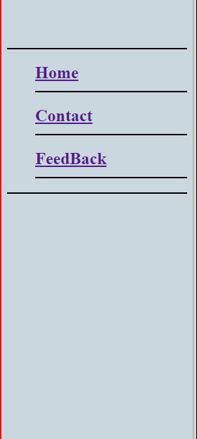
Right Design
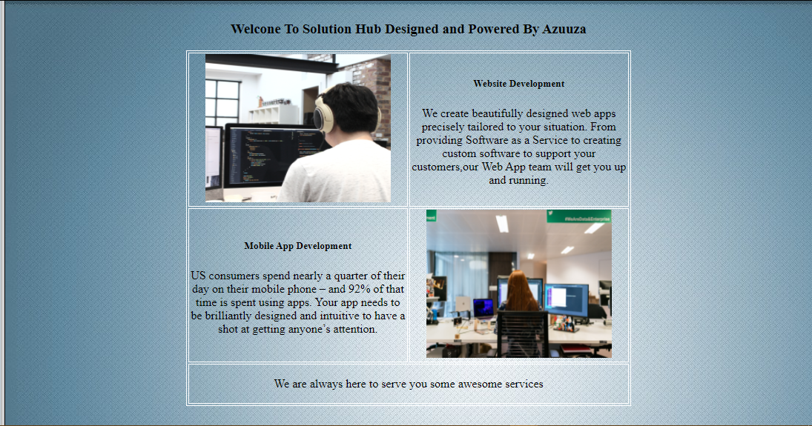

Home Page


Contact Page

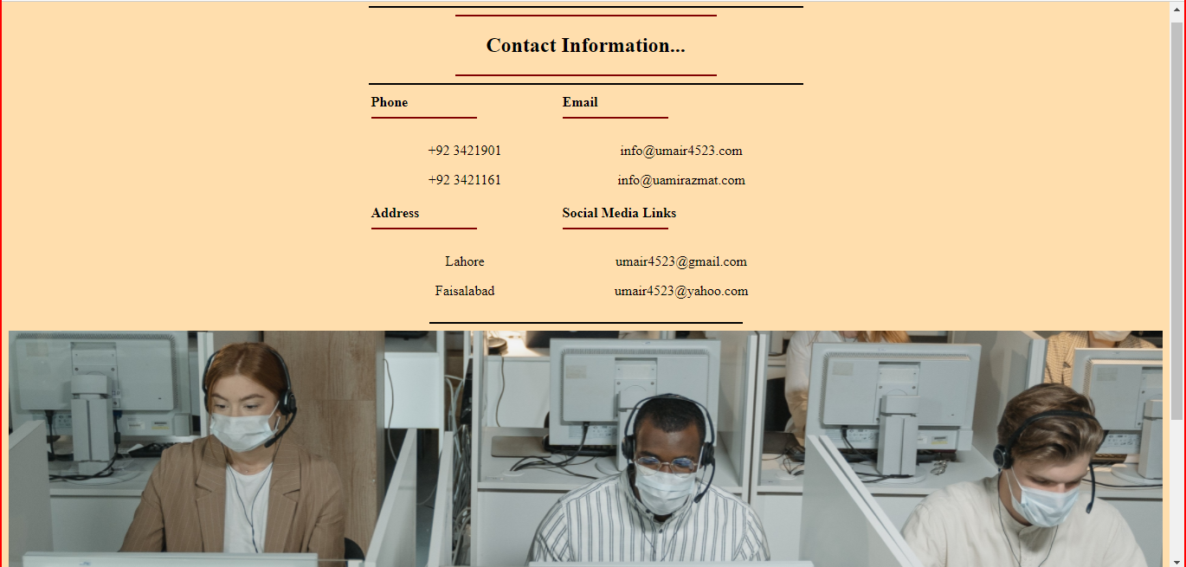
Feedback Page
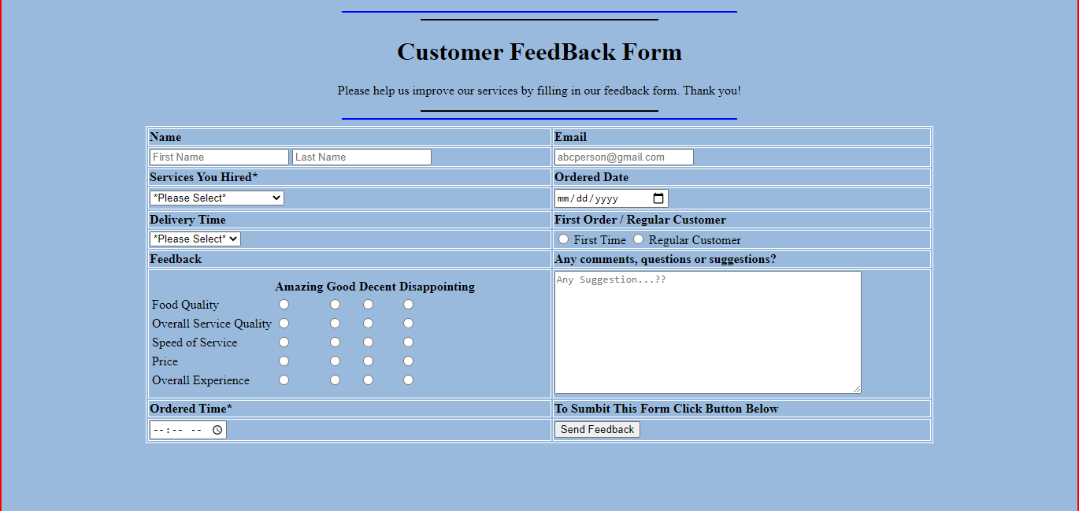

Finished…..

